**ENGINEERING CLINICS**

**PROJECT REPORT**

**AUTOMATION OF WATER PURIFICATION FILTER (HYDAC)**

***Submitted by***

**TEAM - 4**

**S. NEHA 19BEI006**

**R. ANUREKHA 19BEI022**

**S.K. SRIDHAR 19BEI007**

**J. SANJAY KUMAR 19BEI024**

**NITHISH KUMAR 19BEI014**

**ABSTRACT**

**AUTOMATION OF WATER PURIFICATION**

**FILTER (HYDAC)**

The aim of our project is to automate a filter used in the production area of M/s Tamil Nadu News Print and Papers Ltd., (TNPL) the largest Paper Manufacturer in India. A filter brand named as HYDAC is used in water purification system to supply filtered water for paper machine, wire part, forming roll, suction couch roll, sealing strip, flushing and lubrication system with 6-micron filter capacity. Forming Roll plays a vital role in Paper formation. If these roll surfaces are chocked, paper formation will directly get affected. A water shower is provided inside the forming & couch rolls to clean its internals to maintain constant vacuum. The water supplied for these showers must be pure up to 6-micron level.

The HYDAC filter is used for this application. It is having a filter cartridge of 6 filters. This cartridge needs to be cleaned / flushed when it clogs. This will happen when the differential pressure between inlet and outlet of this filter goes beyond 0.5 bar. Due to ageing of the electronic control panel supplied along with this filter is failed and is being operated locally by the field operator. So, the automation of this filter by using SIEMENS LOGO PLC is suggested for the effective performance.

**TABLE OF CONTENTS**

**CHAPTER NO TITLE**

1. **INTRODUCTION**

1.1 INTRODUCTION

1.2 EXISTING PROBLEM

1.3 PROPOSED METHOD

1.4 SUMMARY

**2. COMPANY PROFILE**

2.1 OVERVIEW OF COMPANY

2.2 PAPER MANUFACTURING PROCESS

2.2.1 FORMING SECTION

2.2.2 PRESS SECTION

2.2.3 DRYING SECTION

2.2.4 CALENDER SECTION

2.2.5 CUTTING AND PACKING

**3. HARDWARE DISCRIPTION**

3.1 BLOCK DIAGRAM

3.2 SIEMENS LOGO PLC

3.3 AC-DC CONVERTER POWER

3.4 INDUCTIVE PROXIMITY SENSOR

3.5 SOLINOID VALVES

3.6 DC MOTOR SPEED CONTROLLER

3.7 LAN CABLE

3.8 DC GEAR MOTOR

**4. TECHNICAL DISCRIPTION**

4.1 PLC AND ITS INTERNAL COMPONENTS

4.1.1 CPU MODULE AND MEMORY FUNCTIONS

4.1.2 POWER SUPPLY MODULE

4.1.3 I/O MODULE

4.1.4 DIGITAL I/O MODULE

4.1.5 ANALOG I/O MODULE

4.1.6 COMMUNICATION INTERFACE MODULE

4.2 TYPES OF PLC

4.2.1 COMPACT PLC

4.2.2 MODULAR PLC

4.3 FUNCTIONAL BLOCK DIAGRAM (FBD)

4.4 SOFTWARE DESCRIPTION

4.5 ANIMATION

4.6 CIRCUIT DIAGRAM

4.7 FLOW CHART

4.8 WORKING

**5. RESULTS AND DISCUSSION**

**6. CONCLUSION AND FUTURE SCOPE**

5.1 CONCLUSION

5.2 FUTURE SCOPE

**7. REFERENCE**

**CHAPTER 1- INTRODUCTION**

This chapter introduces the existing method and proposed methodology of HYDAC filter automation using logo PLC.

**1.1 INTRODUCTION**

In TNPL industry the production area consists of head box, wire part, press part, dryer section, calendar section and reel section. The wire part consists of forming roll section and suction couch roll section. The pulp is injected into the wire part through the head box section. Then the paper formation process starts from the wire part section. The wire part drains out around 80% of the moisture from the paper and remaining 20% of moisture is removed by the press part and dryer section. Press part consists of three sections and the dryer part steam heating occurs. So that the maximum moisture from the paper is drained out. In wire part the

suction couch roll and forming roll have suction zones inside them and they are limited by chamber walls. The vacuum process is done by these suction zones as they are connected by the vacuum. Sealing strip is rubber graphite material which are connected between the suction zones and rest of the inner part are of the forming and suction couch roll. These sealing strips were pressed against the inner part of both the rolls. During the vacuum process in wire part, the water content along with debris are sucked through this forming roll and suction couch roll. So that the formation of the debris occurs on the inner part as well as in the sealing strip of both rolls in the wire part, because of the debris formation in sealing strip which causes some damage and poor lubrication problems in sealing strip. To avoid this problem filtered water is used and this filtered water is flushed to the inner walls of the forming roll and suction couch roll so that it can provide better lubrication and improved vacuum process in the wire part.

**1.2 EXISTING PROBLEM**

For the supply of filtered water used in the wire part the company used a filter whose manufacturer named HYDAC. This HYDAC filter’s control panel is not reliable for long period of time and it is not functioning due to ageing factor and its optimum life span is around very few years as printed circuit board is used in its control panel. Due to the malfunctioning of this HYDAC filter’s control panel, the company decided it to operate it in an alternate way by using push buttons and the company is not satisfied with the seller. The operator in the field should check regularly for a certain period of time and it is tedious for the operator as he has to look over other process in the industry.

**1.3 PROPOSED METHOD**

Thus, a solution of automating this filter by using SIEMENS LOGO PLC is suggested as it is very cost efficient, durable, environmentally friendly, fast, flexible and helps in finding error when compared to the HYDAC filter which used the PCB in its control panel.

**CHAPTER 2- COMPANY PROFILE**

**2.1 OVERVIEW OF COMPANY**

TNPL (The Tamil Nadu Papers Limited) is now the leading producer of writing and printing paper with bagasse as the raw material. M/s Beloit Walmsley Limited, UK and M/s Voith paper, Germany are the two companies which have given TNPL three high speed paper machines. These paper machines is capable of carrying out a duplex function of producing newsprint and printing and writing paper. 1200 tons of paper is being produced per day. TNPL was setup by the government of Tamil Nadu in 1984, completing 37 years of operation. The factory is located in Kagithapuram, which is in Karur district of Tamil Nadu. Globally, they are listed in fifteen largest paper industries. The company has seen a tremendous growth, rising from 90000 tons per annum TPA to 400000 TPA at present. High-quality surface sized and non-surface sized papers are being produced by TNPL which are used in modern high speed printing machines. They produce papers having GSM between the range of 50 to 110. From January 1996, TNPL started producing newsprint with its paper machine two. The machine was designed to run only with bagasse. Consuming one million tons of bagasse each year, the company became one of the largest bagasse-based paper mill in the world.

**2.2 PAPER MANUFACTURING PROCES**

The principles of fourdrinier machine is used in modern paper making machines. A continuous paper web is created with a moving woven mesh. This filters out the fibers which are kept in a paper stock. This results in the production of wet mat fiber. As the modern society required a huge amount of printing substrate, the hand paper making process was industrialized. Henry and Sealy Fourdrinier of Britain invented the modern paper machine and patented in 1806.

**2.2.1 FORMING SECTION**

To the head tank, the chest stock is pumped from the machine, which maintains constant head on the stock. The oversized debris like sand and stones are filtered by the centrifugal cleaners, when the pulp slurry is on their way to hand box. Irrespective of the presence of the centrifugal screens, the head box is fed by the fan pump. Distributing the slurry across the wire and to prevent the clumping of fibers is the purpose of head box.

For majority of the paper grades, the headbox consistency is usually below 0.4% where the longer fibers require low consistency when compared to the long ones. Due to high consistency, the more fibers are aligned in the z direction and the low consistency fibred are aligned in the x-y direction. High thickness and stiffness are the characteristics of high consistency while the characteristics of low consistency are high tensile strength which improves formation.

Sheet properties improve even when the consistency is down to below 0.1 %, but it is not practically possible to handle this amount of water. As the fan pump and the headbox are not replaced in time, many paper machines run at a headbox consistency more than the optimum level. The speed of the jet when compared to the speed of the wire is called as the jet to wire ratio. When it is unity, the fibers are drawn out in the direction of the machine. To the conventional fourdrinier, a second headbox is added.

Completely drained base sheet is the suitable location for the secondary headbox. As the fibers of the top and bottom mix together because of the action of water, it is not considered as a separately. On the linerboard, the secondary headboxes are common. Modifying the basic fourdrinier with the addition of second wire is called the top wire former. A top wire helps in improving the formation of the machines whose speed have been increased.

**2.2.2 PRESS SECTION**

Press section is the paper machine’s second section, which helps in removing most of the remaining water through the nips. The pressed water is absorbed and the sheet is given a support using press felts. The consistency of the paper web which leaves the press section can be over 40 %. In the conventional roll presses, one roll is made to be in a fixed position and the other roll is loaded against the fixed roll. The felt goes through the press roll’s nips and several felt rolls usually called the felt run.

The moisture in the sheet transfers to the press felt in dwell time. Suction pickup rolls are used in certain grades of paper, which uses vacuum in order to transfer the sheet between the press sections.

Two vacuum zones are generally present in the vacuum boxes of pickup rolls. Many drilled holes will be present in these rolls, the purpose of which is to allow the vacuum to pass through the rotating roll covering. The sheets are picked up and transferred by the low vacuum zone while moisture is removed by the high vacuum zone. But due to the centrifugal force developed by the high speed, the vacuumed water flings out which makes dewatering difficult. Air movement is required for the pick-up press. In press arrangement, the crown-controlled rolls are the mating rolls. To ensure that the roll does not bow, hydraulic cylinders are present in the press rolls.

**2.2.3 DRYING SECTION**

Steam heated cylinders are used to evaporate the moisture content and thus dries the paper. This is the function of drying section. The maximum steam pressure may be up to 160psig. The end of the dryer is the entry point for steam. Dryer head is the exit for the condensate which comes from the center pipe. Multiple siphons are required for wider machines. It is the centrifugal force which holds the condensate layer in case of fast machines. To improve the heat transfer, the turbulence generating bars are usually used.

The top and bottom of every dryer section comprises of long felt loops which is used to hold the sheet against the dryers. The heat transfer is drastically improved by the felts. Coarse thread is used to make dryer felts. The first bottom dryer section is usually unfelted. Sections is the name given to the paper dryers arranged in groups. The sections are run at a slightly slower

speed as there is possibility of shrinking of sheet. In some cases, more speed is required as some grades of paper stretch when they are run through the machine. There will be some gap present between the sections which are called draws.

For the purpose of conserving heat, the drying sections are enclosed. The pockets are supplied with heated air where the contact between the sheets and the sheets are broken. The rate of drying is increased by this process. The pocket ventilating tubes facing the pocket has slots along the length.

**2.2.4 CALENDER SECTION**

A pressure is applied to the paper, which passes through the calendar section comprising of two or even more rolls. The paper is made much smoother using these calendars. Uniform thickness is also obtained by this process. The finish of the paper depends upon the pressure applied by the rollers, on the web.

**2.2.5 CUTTING AND PACKING**

After the process of calendaring, moisture content in the web will be around 6 % depending on the furnish. Reel drum, which is a cylinder like structure, is used to wound the papers. Between the reel drum and the spool, a constant nip pressure will be maintained which results in friction. This friction is used to spin the spool. A master roll is created when the paper runs through the top of the reel drum and create a spool.

The reel should be capable of shifting quickly switching from the finished roll to the empty spool in order to run the paper machine continuously. During the switching, the flow of the paper should not be disturbed. In order to achieve this, there will be two or more spools in each reel section which rotates throughout the process. An overhead crane is used to load the empty spools above the reel drum, consisting of two primary arms. These arms will bring down the new spool near the reel drum and the paper is torn swiftly by the machine present behind the drum. All these processes are carried out when maximum diameter is reached by the master roll.

Due to the increase in diameter of the paper which is on the spool, it is brought down to the secondary arms and the spool is gradually guided away from the reel drum. To ensure that the roll hardness is within the preferred range, it is checked and adjusted. In the end, the reels of paper which is wound up on the spool is calculated as the full width of the roll minus shrinkage of the paper due to drying of the web which leaves the wire. According to the customer’s needs, the reels of paper are slit into smaller ones in the winder section. An unwind stand is used to place the reel on it. To the desired widths of the orders, the distance between one slitter and the other is adjusted. Before it is being shipped, the winder is made to run till the calculated diameter is reached. These rolls are then labeled according to their sizes.

**tnpl.mp4**

**CHAPTER 3- HARDWARE DESCRIPTION**

**3.1 BLOCK DIAGRAM**

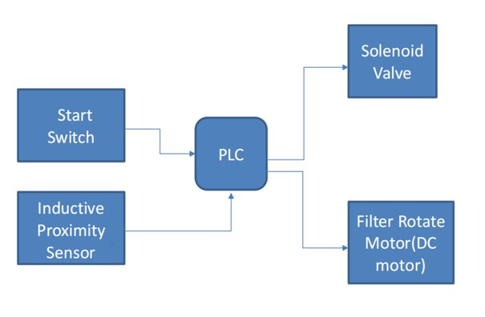

The block diagram of HYDAC filter automation consists of Logo PLC, start switch, current position switch, drain valve, filter rotate motor. There are two digital inputs one is start switch and the other is current position switch and two digital outputs one is drain valve (solenoid valve) and filter rotate motor. When start switch is turned on, the drain valve is opened for certain period of time (in seconds). When the drain valve is closed, filter rotate motor is turned on. When the filter motor rotates the current position will be turned off. The motor will be running until the next current position is detected. This cycle keeps repeating for 5 times and then the circuit will reset.

**3.2 SIEMENS LOGO PLC**

For simple automation work tasks in industries and building services we may prefer Siemen’s logo PLC. As it is flexible due its peculiar modular design. It consists of more than forty modules and the programmers can add up to memory of four hundred blocks. Customers can program their own data and can also make their own libraries. The versions used in our project is 24V RCE. It consists of integrated electrically erasable programmable read only memory for set point values and control program. It can be connected to personal computer by Ethernet cable. It has eight basic modules. Without condensation during operation, it has extended temperature range of -20 to around 55 degrees Celsius. It consists of eight and four digital inputs and outputs respectively. It has a use of standard micro compact flash cards which is optional and also provides some internal memory. Gives maximum ten ampere output current through relay output. It consists of basic as well as special functions. Its dimensions are 71.5mm, 90mm, 60mm width, height, and depth respectively. 3A and 10A are the minimum and maximum inductive load.

The user can create password and it can display the time and also the device is connected or not. Permissible frequency range for lower and higher limit direct current range is from 47Hz to 63Hz respectively. 20.4V and 28.8V is the permissible lower and higher voltage range respectively. The article number used in logo PLC of our project is 6ED1052-1HB08-0BA0.

We give the twenty-four-volt digital input to this PLC.it consists of four eight-bit shift register and also an Ethernet port. It has illuminant backlight display and also has a color choice of three colors. Thus, it is reliable and can give a life span for more than a decade.

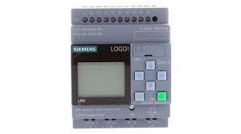

SIEMENS Logo PLC

**3.3 AC-DC CONVERTER POWER SUPPLY**

Wires are being used to transport electric power as DC in a single direction in a constant voltage that is non-oscillating or AC at an oscillating voltage in both directions that is forward and backward. Dominating power is AC due to its advantages on DC, that includes cost and conversion of voltage levels because of transformer. Safety is promised as AC is converted from high to a low voltage for a farther distance. Stored energy is smoothened by a filter and the remaining circuits get a DC source. 230-volt AC is converted to 24-volt DC.

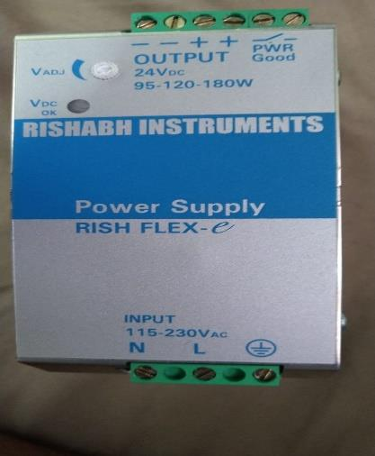

AC To DC Power Supply

**3.4 INDUCTIVE PROXIMITY SENSOR**

A device using electromagnetic induction for object detection and measurement. Flow of current intimates’ occurrence of magnetic field developed by conductor also flow of current inside circuit consisting indicator by changes occurring in magnetic field. Interaction of dirt and liquid with magnetic field is nil. Basic is ‘Faraday’s Law of Induction’. Coil driven sensor including oscillator in one form and production of oscillating magnetic field in other of the inductive sensor. Some specifications are distance detected is 8 mm, inductive type of object, 200 mA of output current, 6 to 36 volts of operating voltage. This comes under non-contact category. Metal objects can be detected and positioned. Long range of sensing for iron and steel as they are ferrous and reduced range of 60% for nonferrous like aluminum and copper.

.

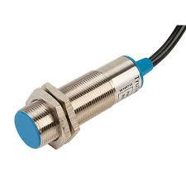

Inductive Proximity Sensor

**3.5 SOLENOID VALVES**

Difference occurs in valve on the basis of current and magnetic field, fluidics uses this often as control elements. In operations like fluid release, distribute and mixture. Found commonly in many areas. Safety in switching and fast switching is offered additionally with high reliability, life in service, good compatibility in components and perfect design. The valve used here is 24V DC with orifice output of 2.5mm. There will be variations in power supply depending on applications like the pressure in fluid and the diameter of the line. These uses are for fluid power pneumatic and hydraulic systems for cylinder controls.

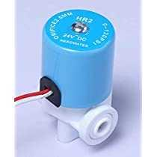

Solenoid Valve

**3.6 DC MOTOR SPEED CONTROLLER**

The DC motor utilizes the electrical power through which it gets the direct current and converts the energy for automatic rotation. With this controller we can control the DC motor using a pulse width modulated DC voltage. Power ratings of different range can be found in these controllers, using the pulse width modulation techniques. The input supply range is from 5V to 30V DC. This controller has a potentiometer which helps in varying the speed of the motor. The duty cycle can be varied from 0 percent to 100 percent. It gives a maximum output power of 80 watts. The battery connection to the motor can be switched 20000 times per second. The motor tallies all these pulses as it cannot detect these much of pulses at a time.

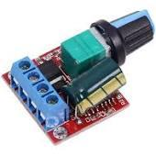

DC Motor

**3.7 LAN CABLE**

The most generally used LAN cable is the ethernet cable. It has a length of cat5 or cat6 cable and RJ45 in each of its ends. It is a lengthier version of the cables which were used to connect the old landline phones. Various lengths of cables are available. But generally, they exchange data up to 100 meters in length. This connects computers which are within a specified range. It began in the 1970’s. the type of cable used here is the fiber cable

which is made up of optical fibers.

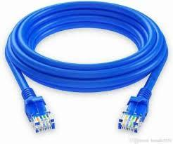

LAN Cable

**3.8 DC GEAR MOTOR**

These types of motors will be suitable for a voltage range of 12V, 24V and devices which has output torque up to 50 kg-cm. These can be used with medium as well as large size motors. Customization of the motor data can be done according to the requirement of the customer. According to the output shaft directions and the categories of the motor gear which are: warm gears, helical gears, bevel gears, dual shaft gears. There are plenty of gear boxes with which we can solve a number of industrial requirements and the space occupied by the machines in the industries is reduced.

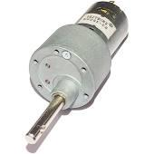

DC Gear Motor

**CHAPTER 4 - TECHNICAL DISCRIPTION**

**4.1 PLC AND ITS INTERNAL COMPONENTS**

It is a programmable logic controller. They are mostly called as industrial computers as their application will be mostly in industrial sectors as they are used for automation purposes. It is able to perform discrete and also continuous function where the personal computers unable to do this function. The user can develop his own program according to the function required and he may able to change the program according to the requirements. These bring a great development to the automation in industries. It also has interior parts similar to as the personal computer. Its basic parts are:

**4.1.1 CPU MODULE AND MEMORY FUNCTIONS**

A central processor and a memory which is present in a CPU. For processing the inputs and outputs that are required are done by the processor. In the memory section both the read only memory (ROM) and Random-Access Memory (RAM) does their jobs spontaneously in operating and storage functions during the process. Always in industries that uses plc for the process of automation as well as monitoring and control they use a retentive memory for the CPU which acts as backup source for the ongoing function in the process as during the process if any power breakdown occurs these retentive memories will be a sudden alternate for the process continuity and also prevents the programmer to enter frequently the power failure occurs. The implementation plan of retentive memory can be done along with the use of batteries with a reliable long-life span, EEPROM modules which may help in storing the program data for the process and also it uses the flash memory method.

**4.1.2 POWER SUPPLY MODULE**

The necessary power required for the total system is given by this power supply system which converts alternating current into direct current power needed for the CPU and the input modules. On the back part of the circuit the bus or rack is provided where all the input and CPU modules are correspondingly plugged in their respective slots. To send and retrieve data between the CPU and input module the communication is been established through this bus. According to the location from CPU modules by the side of the bus the input output module location I determined.

**4.1.3 I/O MODULE**

The sensors, actuators of the system which is connected to the system to measure the real time variable such as temperature, pressure, flow were connected to the system by the input and output modules of the PLC. The variety of this module includes the following due to the type, range, and capabilities.

**4.1.4 DIGITAL I/O MODULE**

For both on off functions these are used as to connect the sensor and actuators provides a digital signal. With many numbers of digital inputs and outputs digital modules can work on both ac and dc voltages.

**4.1.5 ANALOG I/O MODULE**

The sensors and actuators which gives the analog electrical signals are connected through this module. To convert the analog to digital signal a converter is used.

**4.1.6 COMMUNICATION INTERFACE MODULE**

Between the CPU and communication network the information will be exchanged by the help of these modules. The system which are placed away from the PLC for the communication between them this system is used.

**4.2 TYPES OF PLC**

Programmable logic controllers are classified as compact and modular plc.

**4.2.1 COMPACT PLC**

It also known as the integrated PLC. In this type of PLC, there is a single within which there are several modules. Due to this design, it is evident that user has no choice of input and output capabilities. The I/O modules and external I/O cards are fixed in this type. It is up to the manufacturer. In some cases, additional inputs and outputs are allowed to connect, so that it is made slightly similar to the modular type.

**4.2.2 MODULAR PLC**

A modular PLC is built in such a way that it consists of a common rack or bus to which many components are plugged. The I/O capabilities are extendable in this case. In the same rack, the power supply module, CPU and I/O modules are plugged in. It may be from same manufacturers or in some case from other manufacturers. These PLCs are in different sizes, power supply, computing capabilities, I/O connectivity and many more.

**• Small PLC:** This mini sized PLC is placed behind the equipment, which is to be controlled by it. It is a compact and robust unit. Hard-wired relay logics, counters, timers and some other functions are replaced by this type. To only one or two modules the expandability of this PLC I/O module is designed. The programming language used by this PLC is logic instruction list or relay ladder language.

**• Medium-sized PLC:** This is the most widely used PLC in many industries. Using this PLC numerous plug-in modules are placed on the system’s backplane. By adding additional I/O cards, hundreds of input/output points are created. This PLC also provides us with communication module facilities.

**• Large PLC’s:** Wherever complex process control functions are needed; Large PLCs comes into play. In terms of various capacities like memory, programming languages, I/O points, communication modules and others, large PLC’s capacities stand higher than the medium sized one’s. Supervisory Control and Data Acquisition (SCADA) system, larger plants, distributed control systems are some of the areas in which this PLC is used.

**4.3 FUNCTIONAL BLOCK DIAGRAM (FBD)**

It is generally used to program multiple functions. When connection lines are used connect the inputs and outputs, it is called the functional block diagram. One or more output values may be obtained when the program is executed. Inputs to the functional block diagram which is represented as a rectangular block enters from the left and the output leaves in the right side. This kind of connects the input and the output. Function blocks are used to perform the common tasks like counters, timers PID loops.

After the blocks are programmed onto the sheets, either the sheets are scanned in numerical order by PLC or it is based on the connections which are programmed between the blocks.

**4.4 FLOW CHART**

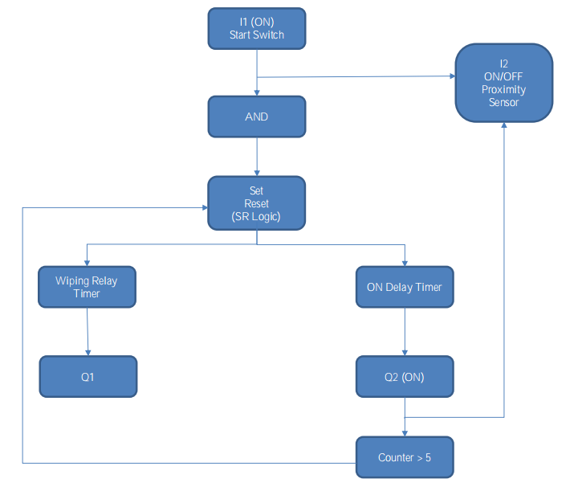

**#** The dirt and dust particles are settled on the walls of the filter. When the accumulation of dirt increases, the flow of outlet water decreases, which results in increase of differential pressure than the set value.

**#** The start switch / sequence can be ON ed by two ways, either manually or in auto mode whenever the differential pressure exceeds the set value.

**#** Once the start sequence is ON, the mechanical home position of 1st proximity sensor is checked. We have used AND logic for starting the cycle. i.e, when both the inputs are true the cycle starts.

**#** Now the filter rotation motor and wiping relay timer is turned ON which in-turn opens the solenoid valve.

**#** Once the filter rotation motor completes one cycle, the drain valve is closed.

**#** The HYDAC filter system is mechanically arranged in such a way that only when the filter rotation motor completes 5 cycles, it will be able to reach mechanical home position.

**#** So, after a set time duration, the filter rotation motor starts its 2nd cycle there by opening the drain valve and the process continues till it completes it’s 5 cycle and reaches its mechanical home position.

**#** Once the 5 cycle is complete, the whole sequence is reset automatically.

**#** The whole sequence starts again only when the differential pressure exceeds the set value once again due to accumulation of dirt.

**4.5 ANIMATION**

**ANIMATION.mp4**

**4.6 CIRCUIT DIAGRAM**

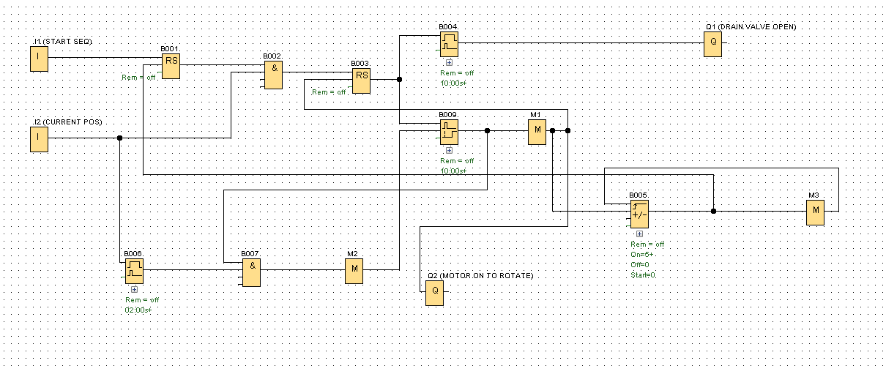

**CONNECTIONS**

Power supply - P1, P2 -24v phase and neutral respectively

Inputs - I1 -start switch

- I2 - present position (proximity sensor position)

Outputs - Q1 -drain valve (solenoid valve)

- Q2 -filter rotation motor

B001 & B003 - latching relay

B004 & B006 - wiping relay (pulse output)

B009 - retentive on-delay timer

**Circuit Diagram.lsc**

**4.7 SOFTWARE DESCRIPTION**

**CASE 1: (I1 - OFF, I2 - ON)**

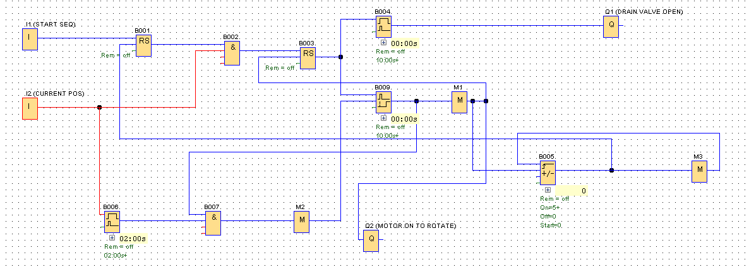

* Initially the position of the proximity sensor that is I2 will be in ON position as it will be currently detecting the metal screw.
* When the differential pressure valve exceeds the set point value, the start sequence is ON either manually / in auto mode.

**CASE 2: (I1 - ON, I2 - ON)**

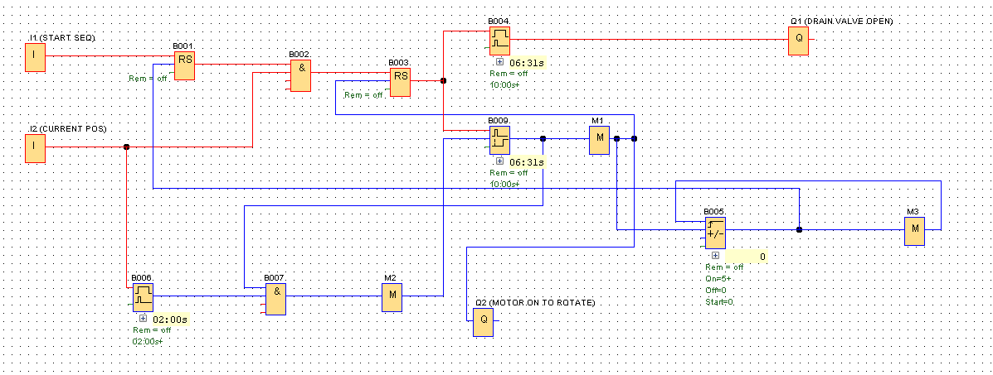

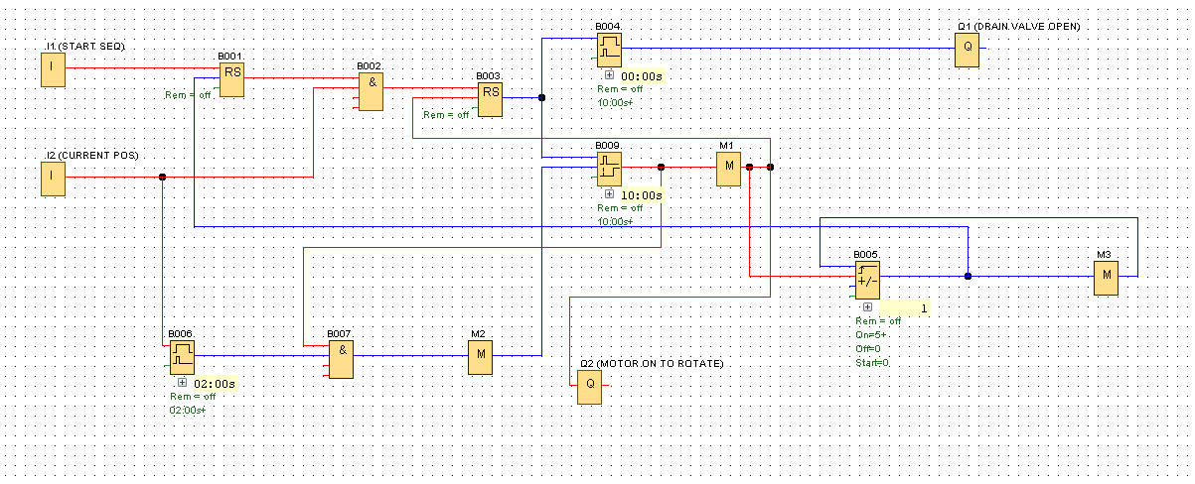

* Once the start switch I1 is ON, the cycle starts. The solenoid valve Q1 will be set open for 10 sec.
* Here we have used RESET logic to start the cycle and also for solenoid valve cycle to reset when the number of cycles in the counter reaches 5.
* When the timer for the solenoid valve ends the solenoid valve gets closed and the motor is ON.

Circuit Diagram.lsc

**4.8 WORKING**

HYDAC filter is a water purifier filter, it just filters the dirt and dust particles present in the inlet water and supplies a pure water outside on continuous basis. The dirt and dust particles are settled on the walls of the filter. When the accumulation of dirt increases, the flow of outlet water decreases, which results in increase of differential pressure than the set value. The start switch / sequence can be ON ed by two ways, either manually or in auto mode whenever the differential pressure exceeds the set value. In this sequence we are using two proximity sensor, one proximity sensor is used in detecting the mechanical home position and the other as the end limit for rotation of filter motor. Once the start sequence is ON, the mechanical home position of 1st proximity sensor is checked. We have used AND logic for starting the cycle. i.e, when both the inputs are true the cycle starts. Now the filter rotation motor and wiping relay timer is turned ON which in-turn opens the solenoid valve. Once the filter rotation motor completes one cycle, the drain valve is closed. The HYDAC filter system is mechanically arranged in such a way that only when the filter rotation motor completes 5 cycles, it will be able to reach mechanical home position. So, after a set time duration, the filter rotation motor starts its 2nd cycle there by opening the drain valve and the process continues till it completes it’s 5 cycle and reaches its mechanical home position. Once the 5 cycle is complete, the whole sequence is reset automatically. The whole sequence starts again only when the differential pressure exceeds the set value once again due to accumulation of dirt.

**CHAPTER 5 - RESULT AND DISCUSSION**

When the start switch is triggered, the sequence starts. The proximity sensor is already in detection and giving an input, when the start switch is switched ON, the filtration cycle starts. We have given AND logic for stating the cycle, when both inputs are true the cycle starts. Wiping Relay timer is used for drain valve and ON Delay timer for motor rotation and the same amount of time is given for both relays so when the drain valve is closed, the motor will rotate and when the proximity detects the next cycle will start. This cycle repeats for 5 times, then the circuit will be RESET by using SR logic gate.

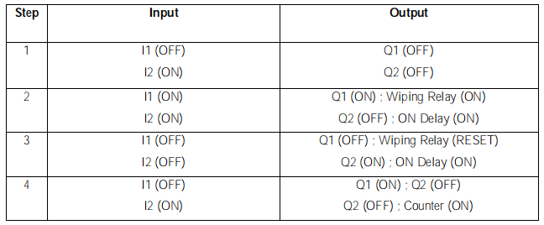

**CHAPTER 6 - CONCLUSION AND FUTURE SCOPE**

**6.1 CONCLUSION**

Functional block diagram used for simulation in logo soft comfort version 8.2 software and logo PLC as a replacement for the faulted printed circuit board of the HYDAC filter. HYDAC filter is automated as control panel got fault due to ageing. The company implemented this logo PLC on the control panel instead of buying another printed circuit board from HYDAC company manufacturer as its control board costs are higher than this mini-PLC.

**6.2 FUTURE SCOPE**

The output of the filter capacity is 2 bar and this can be implemented also for 20 bar filter in TNPL industry. The cost reduced is around 3 lakhs as implementing PLC in the control panel of HYDAC filter.

**CHAPTER 7 – REFERENCE**

1. Francesco Basile “On the Implementation of Industrial Automation Systems Based on PLC” IEEE Transactions on Automation Science and Engineering (Volume: 10, Issue: 4, Oct. 2013).
2. Fabian M. and Hellgran A. “PLC-based Implementation of Supervisory Control for Discrete Event Systems”, in Proceedings of the 37th IEEE Conference on Decision & Control, Tampa, Florida, USA, (1998).
3. Herbsleb, James & Paulish, Daniel & Bass, Matthew. (2005) “Global software development at SIEMENS" 524. 10.1145/1062455.1062550.

4. Dong Yulin; Zheng Chunjiao, “Design and research of embedded PLC development system”,

IEEE, March 2011.